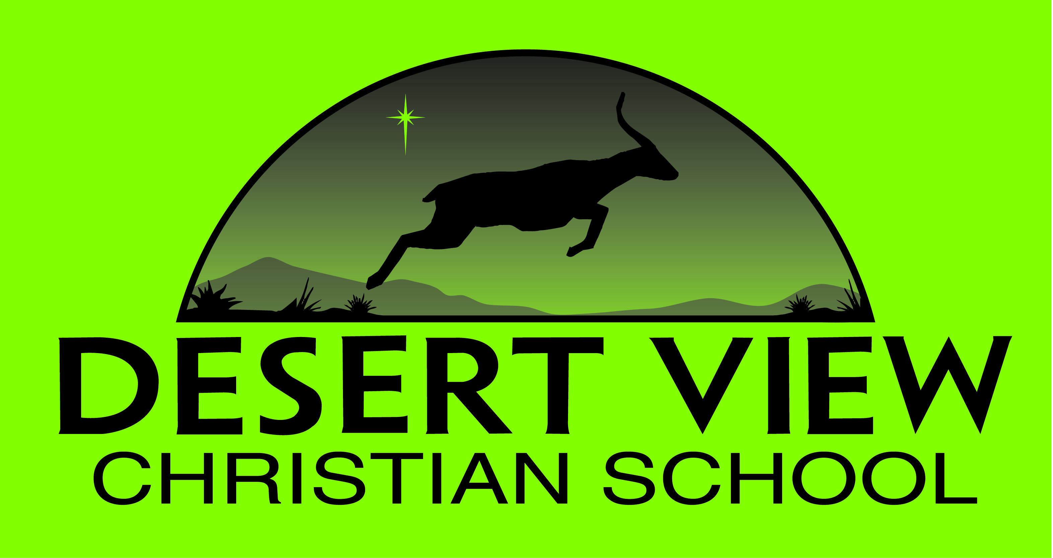
PERMISSION TO RELEASE PHOTOGRAPHIC IMAGES
Requesting School:
Desert View Christian School
Mountain Home, ID 83647
Permission to release of the following student(s):
Student Name _________________________________ Date of Birth __________________________
Student Name _________________________________ Date of Birth __________________________
Desert View Christian School takes privacy seriously. By signing this form you are authorizing the use of photos to be taken by the school of your child. This form release is for those photos to be used for the purposes of school publications such as our website and for any public relations documents.
Desert retains these photos on a secure platform site and will never use them except for the aforementioned purposes. Should you decide at any point to rescind this permission for use of these photos please resubmit another form stating this.

I hereby permit the release of the above student’s photographic images for the explicit use of the Desert View Christian School to create school publications and public relations documents.
YES ☐ NO ☐

Parent/Guardian Signature _____________________________________ Date _____________________________

Desert View Christian School ~ 2425 American Legion Blvd. Mountain Home, ID 836347 ~ (208)580-0512

